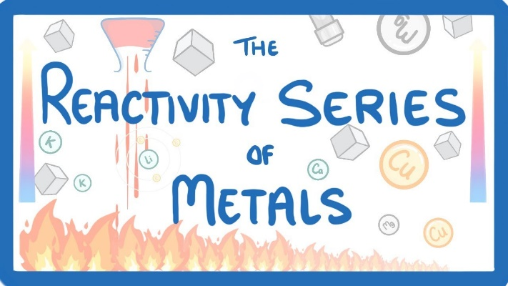

**The Basic Ideas**

1. When a metal reacts and forms a compound it is oxidised and becomes an ion.

Example: the burning of magnesium

2Mg(s) + O2(g) 🡪 2MgO (the redox reaction)

Mg(s) 🡪Mg2+(s) + 2e- (the half equation)

Similar half equations can be written for all metals.

1. Some metals are oxidised more readily than others (we say they are more reactive)

Example: sodium is oxidised more readily than copper and is therefore more reactive

The easier a metal is oxidised the more difficult it is to reduce (go backwards)

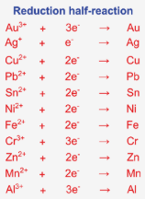

1. Chemists have measured how easily a metal is oxidised, and this is shown in a table called the Standard Reduction Potentials
   * In this table the half reactions are written in the reduction direction (hence the name)
   * The half equations are placed with the easiest to reduce (strongest oxidising agents) at the top and the most difficult to reduce (weakest oxidising agents at the bottom.
   * Part of this table is shown in the table to the right

**Examples of using this table**

**Determine the reactivity of metals**

Because they are written in the direction, a metal higher in the reactivity series is more reactive than a metal shown further up. e.g. aluminium is more reactive than silver.

**Determine is a displacement reaction will occur**

A metal higher up in the metal reactivity series will displace a metal further down in solution. e.g. aluminium will displace silver ions in a solution.